Commonwealth Women Parliamentarians Steering Committee Meeting,
Sydney, Australia, 3 November 2024
Canadian Region
- Data on the number of women representatives  Including:  Statistics in legislatures, executive, company boards  Changes in representation following elections  Affirmative Action policies, as they relate to quotas, constitutional, legislative, electoral changes  Political Party Reforms and appointments of women within the Party Structures | 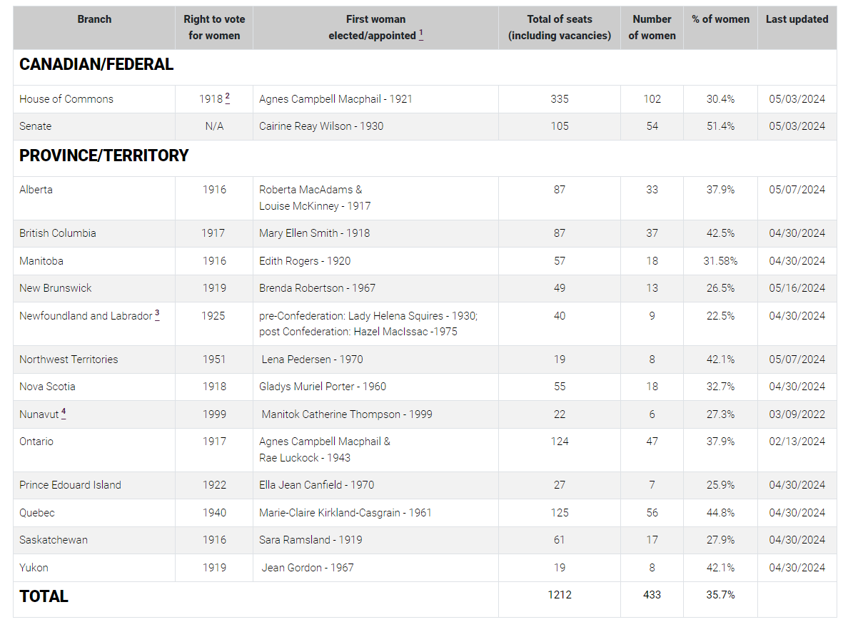  Women serving as leaders of political parties which hold legislative seats at the provincial and territorial level as of September 2024  Leaders Political Party Province  Carla Beck New Democratic Party Saskatchewan  Karla Bernard Green Party PEI  Claudia Chender New Democratic Party Nova Scotia  Bonnie Crombie Liberal Party Ontario  Sonia Furstenau Green Party British Columbia  Susan Holt Liberal Party New Brunswick  Christine Labrie Québec solidaire Quebec  Cindy Lamoureux Liberal Party Manitoba  Danielle Smith United Conservative Party Alberta  Marit Stiles New Democratic Party Ontario  Kate White New Democratic Party Yukon  - Elizabeth May (Green Party) is the only woman leader of a federal political party represented in Parliament.  - Of the 13 provincial and territorial governments, Danielle Smith (Alberta) is the only woman premier.  - The federal cabinet continues to have gender parity.
- Information on elections that were held this year  Including:  Data on women Members that won and/or lost seats or appointed to new positions | - There are three provincial elections being held in October 2024 (British Columbia, New Brunswick and Saskatchewan). The next federal election is scheduled for October 2025.
- Status of the CWP in regional constitutions  Including:  Updates in Regional Constitutional changes and/or challenges where applicable | - In the Canadian Region, the CWP has its own constitution that lays out its aims and objectives and provides a structure. The steering committee is composed of one representative from each of the 14 branches and a Chair. The Chair rotates every three years, with the Alternate Chair assuming the Chair position. The steering committee manages the business of the CWP network between annual meetings.
- CWP Regional Structure  Including:  Updates on changes and/or challenges to Regional CWP Structures | - One of the most significant challenges for our Region’s steering committee concerns finding resources for virtual meetings. Specifically, simultaneous interpretation is required as members can be unilingual English or French. There are significant costs associated with ensuring that interpretation services are available and that members have the required technological equipment and headsets to participate fully.
- Regional Budget for CWP Activities  Including:  Updates on changes and/or challenges to Regional CPA Budgets where applicable | - The Region provides CWP with an annual budget of $35,000 to fund its activities. The annual budget usually allows for the Region’s CWP Chair and secretary to attend the CPC. The budget will also cover the Chair’s travel expenses for the annual Regional Conference and pay travel costs to speakers invited to address the conference attendees on a day dedicated to the CWP during the conference. Additional funds are set aside for the Chair and secretary’s travel to an annual outreach program hosted by one of the branches and to allow for the Chair, or an alternate, to attend a CWP workshop during the year. Lastly, funds have been used in the past to support individual branches who choose to run twinning programs between young women and women parliamentarians.  - One of the challenges faced by the CWP in our region is that the funding was insufficient to allow for larger activities and were therefore rarely ever spent in entirety, so significant amounts of funding were being returned to the Region each year. This year, the CWP steering committee requested, and was granted, the right to retain the unspent funds each year. This should permit the CWP to carry out some larger scale activities in the years to come.
- Regional Conference – What role did CWP play?  Including:  Updates on changes and/or challenges to holding a regular CWP meeting at CPA Regional Conferences  Updates on Regional CWP activities | - As per the CWP’s constitution, two days are dedicated to meetings at each Regional Conference. The first day is for the steering committee to meet, while the CWP hosts a conference with panelists on the second day. This year, the theme of the conference was “Women and Action”.  The attendees heard from women in politics who are also leaders. Panelists shared their stories and there was much discussion about how to attract more women to politics, as well as what is working and what isn’t. Perhaps the most inspiring part of the conference was hearing from women who are not in politics; the discussion was a clear and poignant reminder of why it matters that there are women in the legislatures in the first place. We heard from Keri Gray - an entrepreneur whose rabbit products were developed to feed her child, and evolved into a farm and pet-treat company that hires Indigenous youth from Keri’s reserve. We heard from Margaret Evans who is a producer at Balancing Act which brings focus to the issue of compassionate budgeting and we heard from Manavi Handa, a practicing midwife and professor of midwifery who is advocating for health coverage for newcomers who are pregnant and often don’t seek the care they should because of the costs.  We are looking forward to continuing these important discussions next year when we gather in Quebec City.
- CPA International Executive Committee – does your region have a female Member?  Including:  Updates on changes to Regional Representatives to the CPA International Executive Committee | - Yes – Donna Skelly, MLA and Deputy Speaker of the Legislative Assembly of Ontario, represents the Canadian Region on EXCO.
- Initiatives linked to CWP Thematic Priorities undertaken by Parliaments and/or Regions  Including:  Legislation, resources, Inter-organizational strategies, Intra-Ministerial and Civil Society Cooperation and all other strategies related to the following –  - Women in leadership;  - Elimination of Gender-Based Violence (GBV) in all of its forms;  - Economic Empowerment of Women;  - Equal access to national resources | - Federally, Hon. Karina Gould, Government House Leader, took six months of maternity leave following the birth of her second child in early 2024. This was the first time that a sitting MP took advantage of the 2019 legislative changes that made Canadian parliamentarians eligible for parental leave.  - In December 2023, new regulations took effect such that federally regulated employers are now required to provide menstrual products, such as pads and tampons, to any employee who needs them while on the job at their workplace by making them available in an accessible and private workplace location, such as a washroom or office supply cabinet.  - In Ontario, the government expanded its Menstrual Equity Initiative by making sure schools across Ontario can offer free menstrual products to their students.  - On March 19, 2024, Bill C-35, An Act respecting early learning and child care in Canada received Royal Assent, The bill sets out the Government of Canada’s vision for a Canada-wide, community-based early learning and child care system and its commitment to ongoing collaboration with the provinces and Indigenous peoples to support them in their efforts to establish and maintain such a system and the preamble acknowledges the beneficial impact of early learning and child care on child development, on the well-being of children and of families, on gender equality, as well as on the rights of women and their economic participation and prosperity and on Canada’s economy and social infrastructure.
- The Contribution of women parliamentarians to The Parliamentarian journal article | - Volume 105 (Issue One) of the Parliamentarian from early 2024 featured an article by the Hon. Laura Ross, Saskatchewan Minister Responsible for the Status of Women and former Chair of the Canadian Region’s CWP network. The article was entitled “She Should Run: Inspiring Tools and Supports for Women Interested in Seeking Elected Positions.” The focus of the article was on why women should run for political office, and she spoke about her own motivation for doing so. As the Region’s CWP Chair, she led a research project that resulted in a publication called “She Should Run”, which brought together various tools to help women build strong electoral campaigns.  - Alexandra Mendès, MP and Deputy Speaker of the Canadian House of Commons, contributed an article in Volume 105 (Issue Two). The article was included in the section entitled “Reflecting on the 75th anniversary of the ‘modern’ Commonwealth”.  - Karen Vecchio, MP, contributed an article in Volume 105 (Issue Three). The article focused on the challenges by women who take on parliamentary leadership roles.
- Other

Including, for example:

Strategies to Overcome Gender Inequality
Education
Gender Quotas
Leadership programmes
Childcare
Mechanisms to prevent political violence
Equal access to Party resources
Coordination with other like-minded Women’s organizations

